Devin Hunter

08/13/22

CS 255: System Analysis and Design

Professor Yurik

**CS 255 System Design Document**

**UML Diagrams**

UML Use Case Diagram

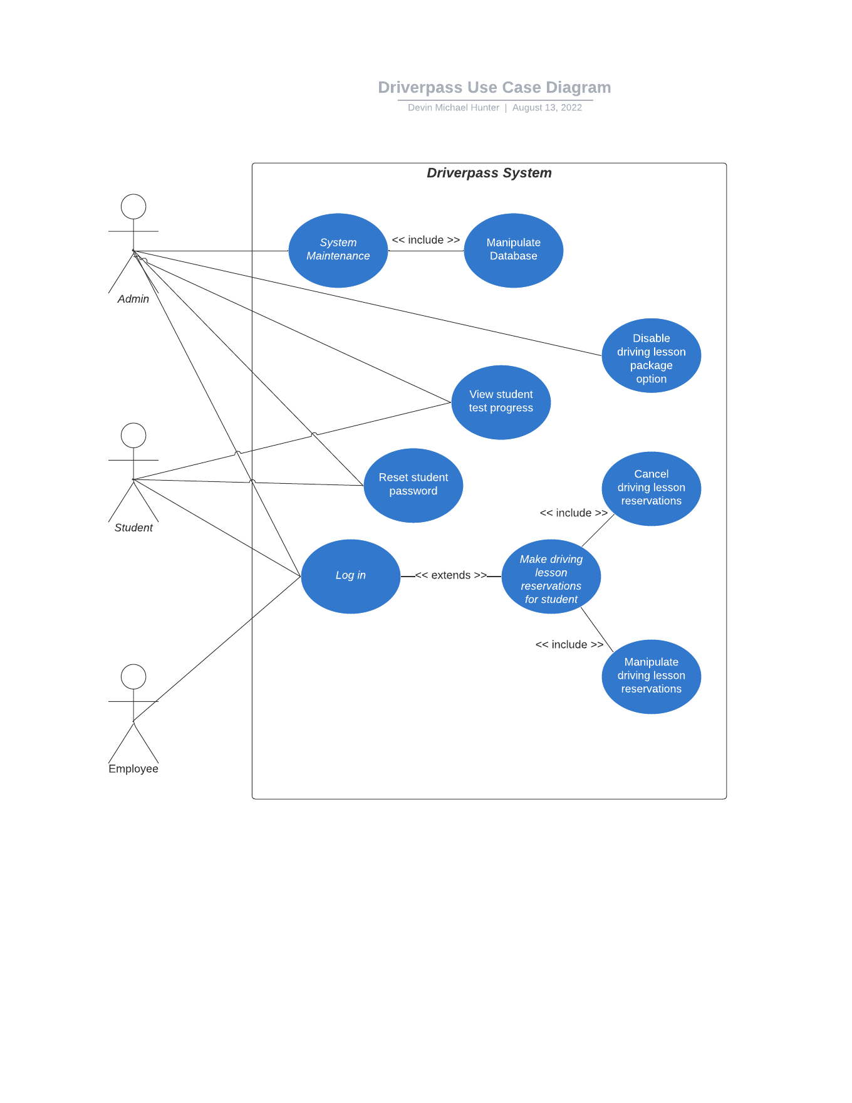

UML Activity Diagrams

Student Login UML Activity Diagram

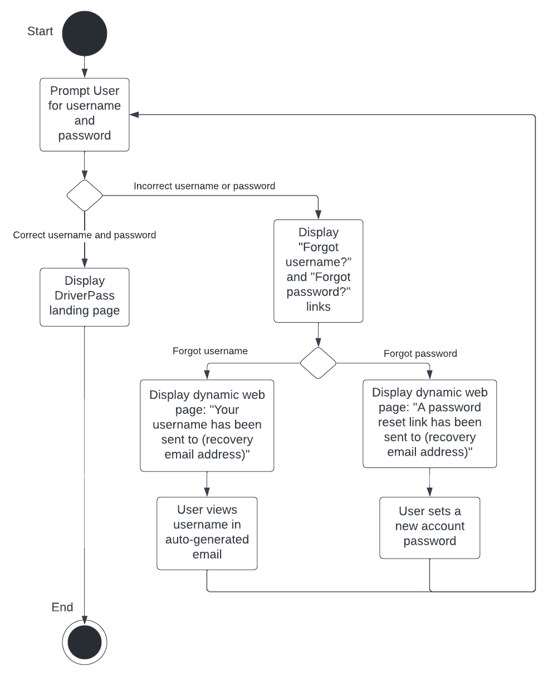

Student Password Reset UML Activity Diagram

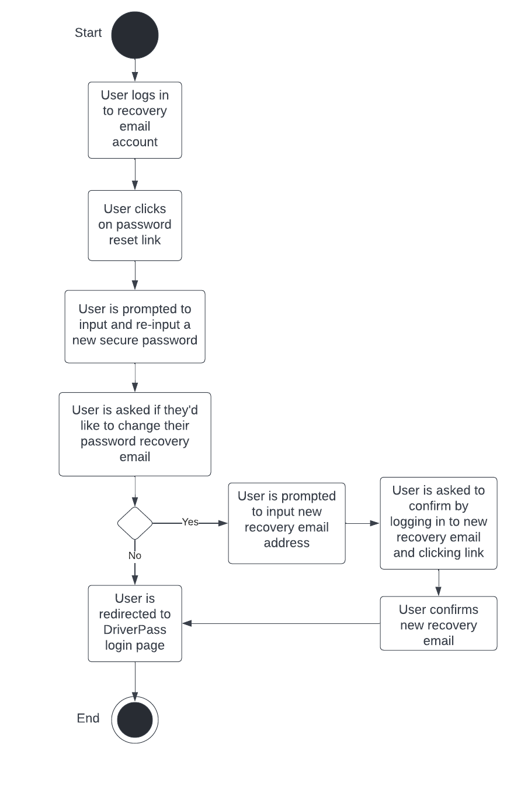

UML Sequence Diagram

Successful Student Login Sequence Diagram

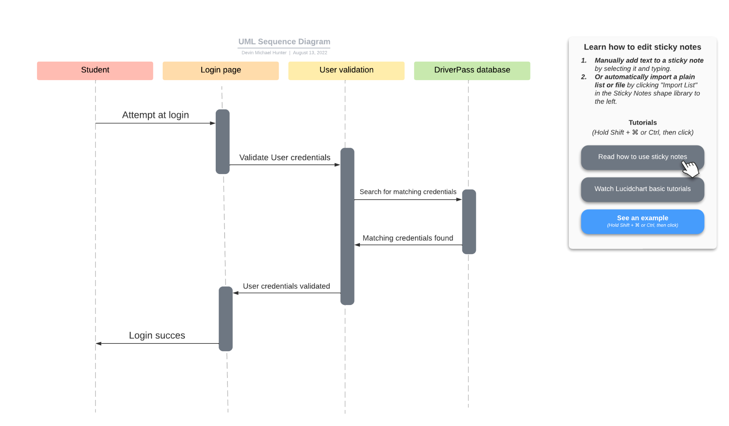

DriverPass UML Class Diagram

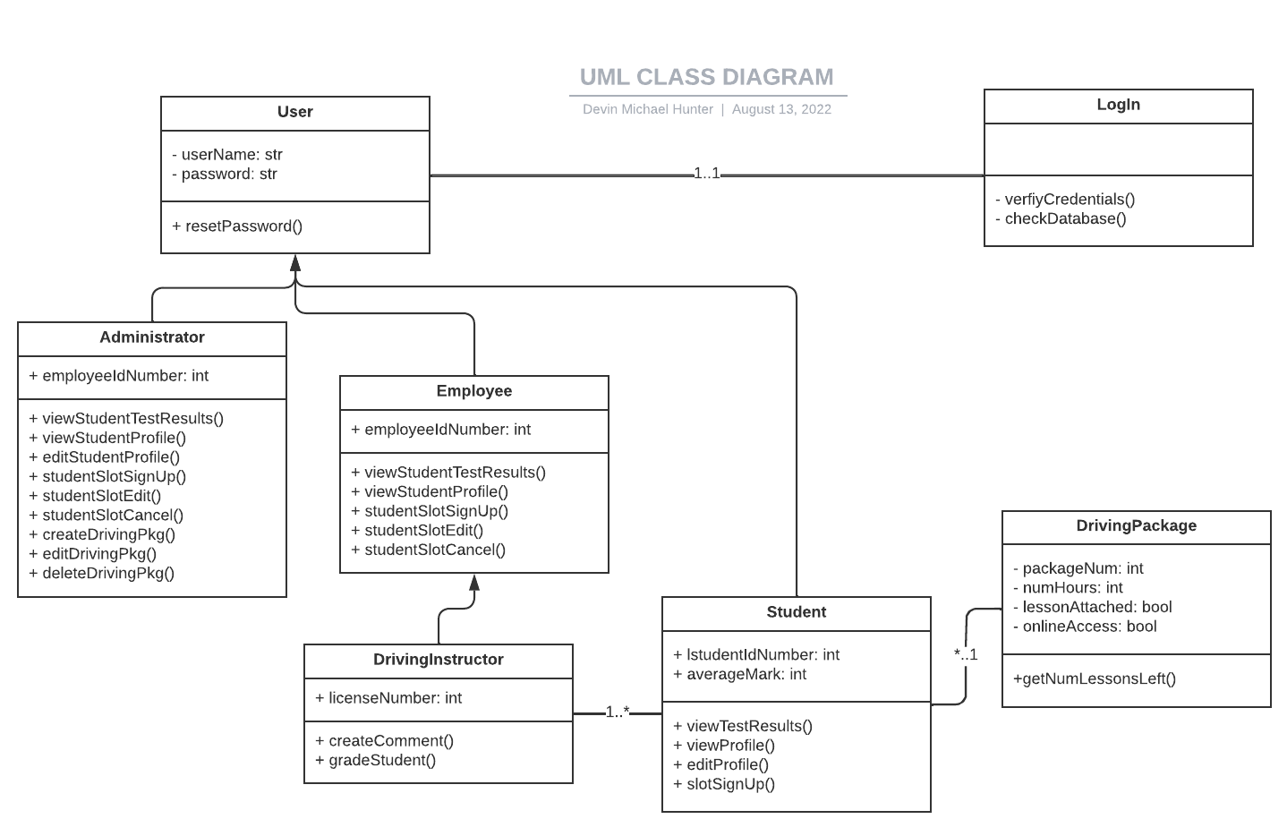

Technical Requirements

Hardware

* DriverPass’ new system shall be accessible from any device, mobile or otherwise.

Software

* The system shall be web-based.
* The system shall be available via all modern browsers.
* The UX shall be designed with a mobile-first approach to ensure the best experience on all screen resolutions.
* Employees will receive a notification upon any DMV policy change.

Tools

* System admins shall be able to create, edit, or disable driving packages.
* Driver employees shall be able to leave comments for students post driving lesson.
* Students shall be able to schedule or cancel driving lessons.
* Employees shall be able to schedule, edit, or cancel driving lessons for students.
* Students shall be able to select a driving package.
* Students shall be able to see their past test scores.
* Students shall be able to see cumulative test scores.
* Students shall be able to upload a photo to their profile.
* Students shall be able to see any comments on past driving lessons.

Security

* Users shall be able to login to the system with a username and password.
* Admins shall be able to reset passwords for students.
* Students shall be able to reset their own passwords.
* Students shall be able to set a recovery email.
* Logins shall be verified by the system by checking the database for matching credentials.

Infrastructure

* DriverPass’ new system shall be hosted via cloud service.
* The database for DriverPass’ system shall also be hosted via cloud service.